Kubernetes Task-05

1.Create a namespace dev-environment and apply a resource-based quota that restricts the number of pods to 3 and services to 2.

Step 1: Create Namespace and ResourceQuota YAML

apiVersion: v1
kind: Namespace
metadata:
name: dev-environment

---
apiVersion: v1
kind: ResourceQuota
metadata:
name: dev-quota
namespace: dev-environment
spec:
hard:
pods: "3"
services: "2"

Explanation:

* Namespace → creates an isolated environment called `dev-environment`
* ResourceQuota → limits resources in that namespace
* pods: 3 → maximum 3 pods allowed
* services: 2 → maximum 2 services allowed

Step 2: Create the YAML File

vi dev-namespace-quota.yaml

Paste the YAML and save.
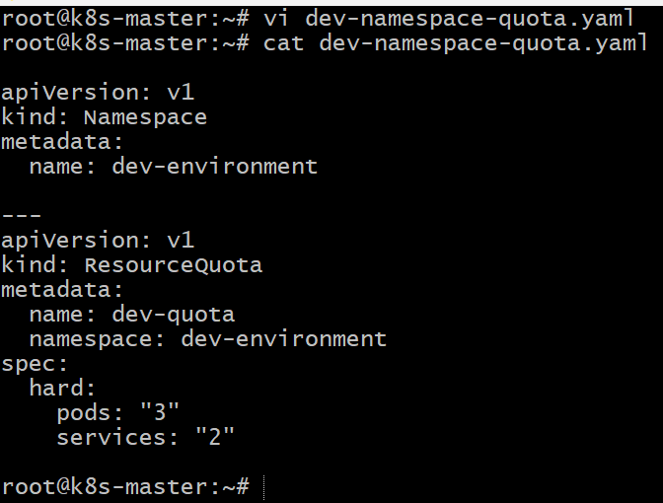

Step 3: Apply the Configuration

kubectl apply -f dev-namespace-quota.yaml

Expected output:

namespace/dev-environment created
resourcequota/dev-quota created
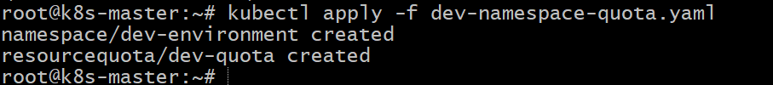

Step 4: Verify Namespace

kubectl get ns

Example output:

NAME STATUS AGE
dev-environment Active 10s
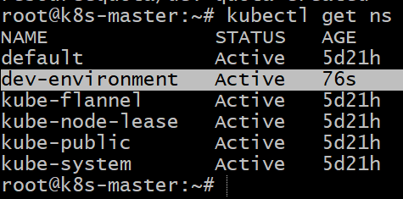
Step 5: Verify ResourceQuota

kubectl get resourcequota -n dev-environment

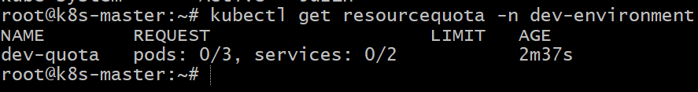
Detailed view:

kubectl describe resourcequota dev-quota -n dev-environment

kubectl describe resourcequota -n dev-environment

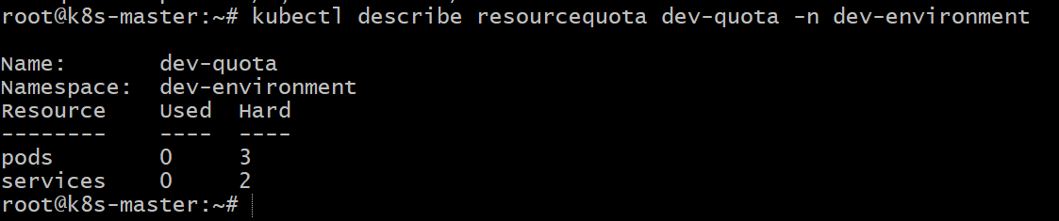

- Conclusion

In this task, we created a namespace named `dev-environment` and applied a ResourceQuota to control resource usage within that namespace. The quota restricts the environment to a maximum of 3 pods and 2 services, ensuring efficient resource management and preventing excessive resource consumption in the Kubernetes cluster.

- Create a pod in the prod-environment namespace with 0.2 CPU and 200Mi memory requests, and 0.5 CPU and 500Mi memory limits.

Step 1: Create Pod YAML

apiVersion: v1
kind: Namespace
metadata:
name: prod-environment

---
apiVersion: v1
kind: Pod
metadata:
name: nginx-pod
namespace: prod-environment
spec:
containers:
- name: nginx-container
image: nginx:latest
resources:
requests:
cpu: "200m"
memory: "200Mi"
limits:
cpu: "500m"
memory: "500Mi"
ports:
- containerPort: 80

Explanation:

* Namespace → creates an isolated environment called `prod-environment`
* requests → minimum resources required by the pod.
* limits → maximum resources the container can use.
* 200m CPU = 0.2 CPU, 500m CPU = 0.5 CPU.

Step 2: Create the YAML File

vi prod-pod.yaml

Paste the YAML and save.

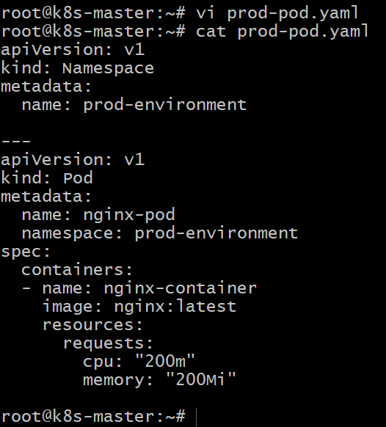

Step 3: Apply the Configuration

kubectl apply -f prod-pod.yaml

Expected output:

namespace/prod-environment created
pod/nginx-pod created

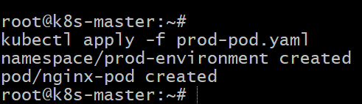

Step 4: Verify the Pod

kubectl get pods -n prod-environment

Example output:

NAME READY STATUS RESTARTS AGE
nginx-pod 1/1 Running 0 15s

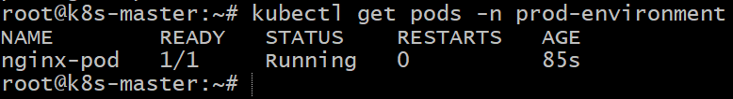

Step 5: Verify Resource Requests and Limits

kubectl describe pod nginx-pod -n prod-environment

Check under **Containers → Limits and Requests**.

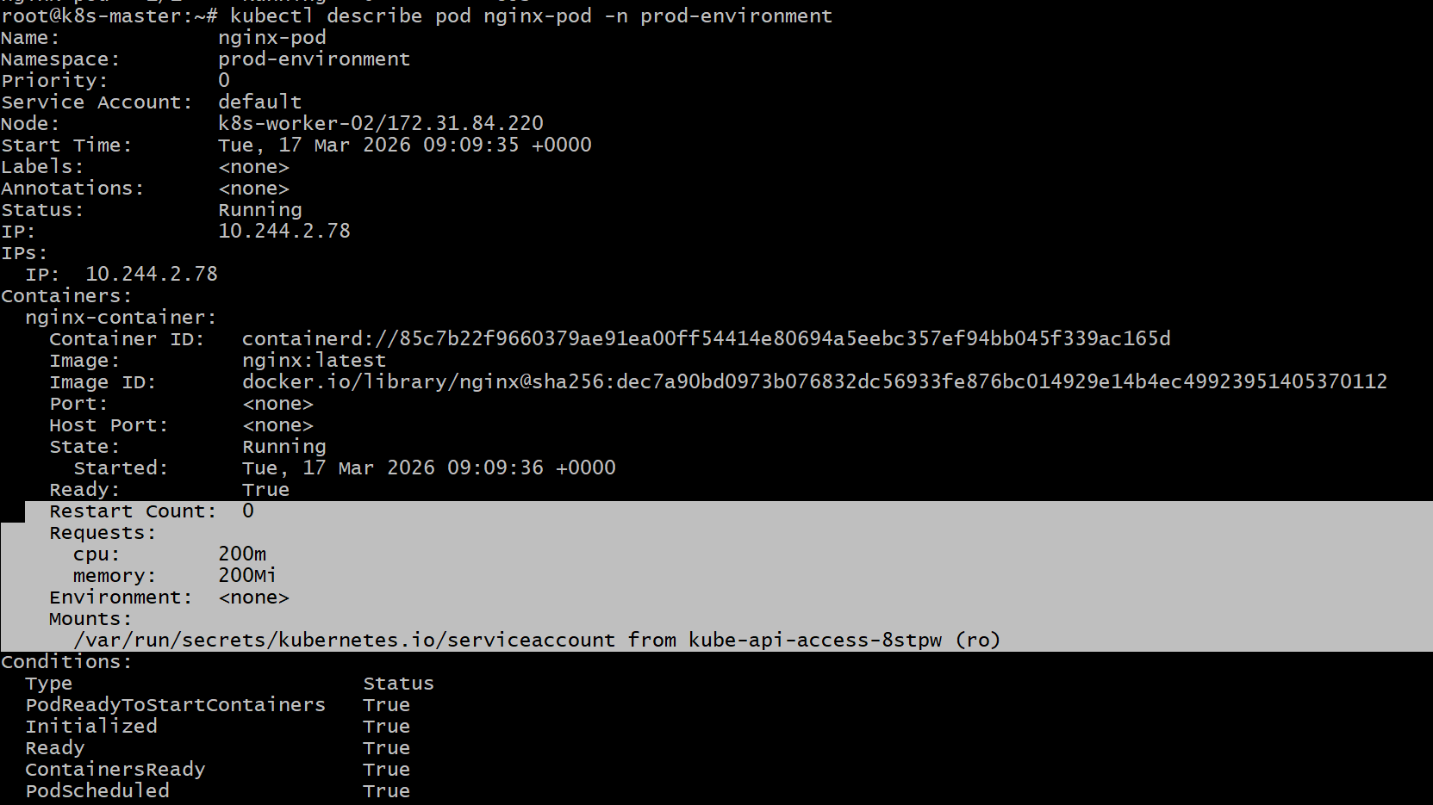

- Conclusion

In this task, we created a **pod in the `prod-environment` namespace** and configured **CPU and memory resource requests and limits**. The pod requests **0.2 CPU and 200Mi memory** as minimum resources and limits usage to **0.5 CPU and 500Mi memory**. This helps Kubernetes schedule the pod efficiently and prevents it from consuming excessive cluster resources.

- In the staging-environment namespace, set a LimitRange that assigns default CPU and memory limits (300m CPU, 600Mi memory) and applies a minimum and maximum CPU.

Step 1: Create LimitRange YAML

apiVersion: v1
kind: Namespace
metadata:
name: staging-environment

---
apiVersion: v1
kind: LimitRange
metadata:
name: staging-limitrange
namespace: staging-environment
spec:
limits:
- type: Container
default:
cpu: "300m"
memory: "600Mi"
defaultRequest:
cpu: "200m"
memory: "300Mi"
min:
cpu: "100m"
max:
cpu: "500m"

Explanation:

* Namespace → creates an isolated environment called `staging-environment`
* default → automatically assigns limits if not specified
* defaultRequest → default resource request for containers
* min → minimum CPU allowed
* max → maximum CPU allowed

Step 2: Create the YAML File

vi staging-limitrange.yaml

Paste the YAML and save.

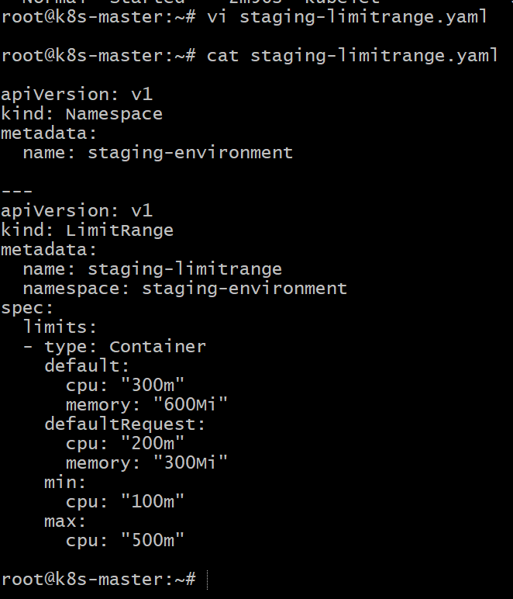

Step 3: Apply the LimitRange

kubectl apply -f staging-limitrange.yaml

Expected output:

namespace/staging-environment created
limitrange/staging-limitrange created

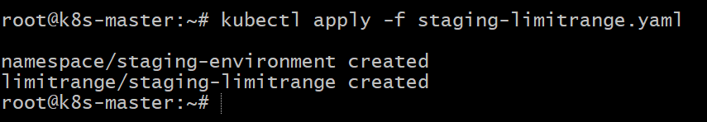

Step 4: Verify the LimitRange

kubectl get limitrange -n staging-environment

Detailed view:

kubectl describe limitrange staging-limitrange -n staging-environment

kubectl describe ns staging-environment

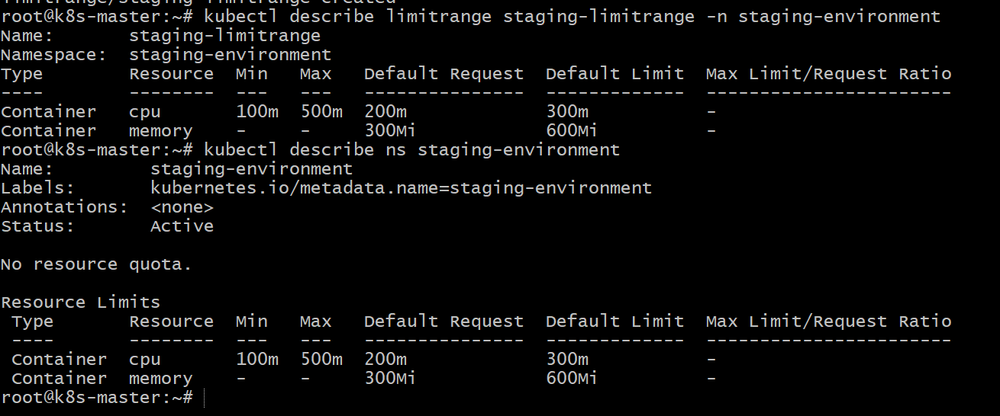

- Conclusion

In this task, we configured a LimitRange in the `staging-environment` namespace to control resource allocation for containers. The LimitRange assigns default limits of 300m CPU and 600Mi memory, along with default requests, and enforces minimum and maximum CPU constraints. This ensures that containers created in the namespace follow consistent resource usage policies and prevents overconsumption of cluster resources.

- Create a pod and a NodePort service in the default namespace, then create another pod in the test namespace and communicate between them using Service DNS.

Step 1: Create Pod and NodePort Service (default namespace)

Create a file called **`nginx-nodeport.yaml`**

vi nginx-nodeport.yaml

apiVersion: v1
kind: Pod
metadata:
name: nginx-pod
labels:
app: nginx
spec:
containers:
- name: nginx-container
image: nginx:latest
ports:
- containerPort: 80

---
apiVersion: v1
kind: Service
metadata:
name: nginx-service
spec:
type: NodePort
selector:
app: nginx
ports:
- port: 80
targetPort: 80
nodePort: 30009

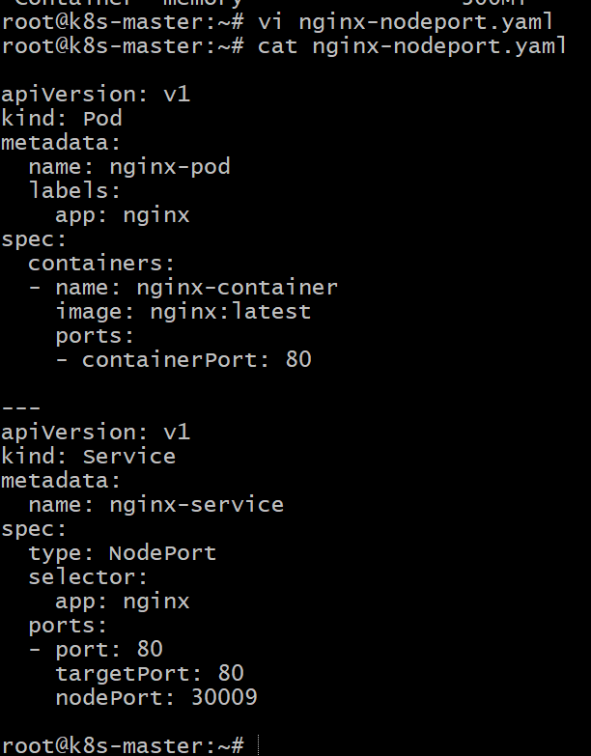

Step 2: Apply the YAML

kubectl apply -f nginx-nodeport.yaml

Expected output:
pod/nginx-pod created
service/nginx-service created

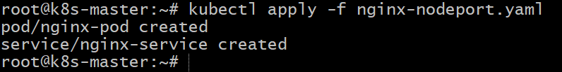

Step 3: Create a New Namespace

kubectl create namespace test
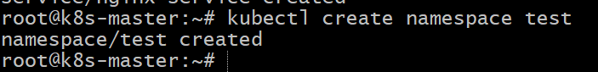

Step 4: Create a Pod in **test** Namespace

Create file **`test-pod.yaml`**

vi test-pod.yaml

apiVersion: v1
kind: Pod
metadata:
name: test-pod
namespace: test
spec:
containers:
- name: busybox-container
image: busybox
command: ["sleep","3600"]

Apply it:

kubectl apply -f test-pod.yaml

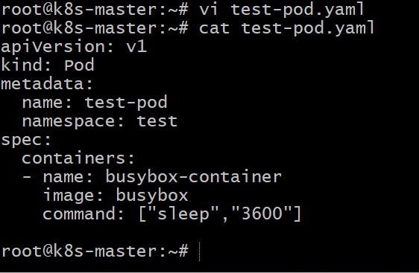
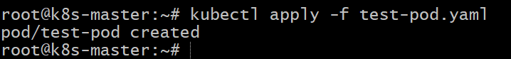

Step 5: Verify Pods

kubectl get pods

kubectl get pods -n test
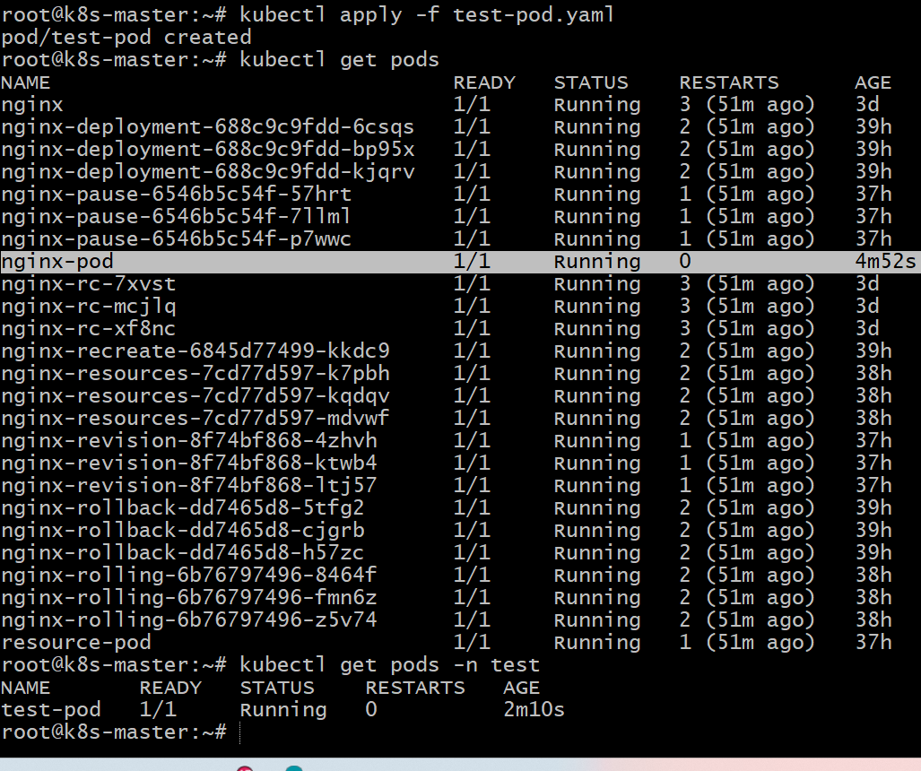

Step 6: Communicate Using Service DNS

Access the pod:

kubectl exec -it test-pod -n test -- sh

Inside the pod run:

wget -qO- http://nginx-service.default.svc.cluster.local

Part | Meaning
wget | Tool to fetch web content
-q | Quiet mode
-O- | Print output to terminal
URL | Service DNS name

Explanation of DNS:
<service-name>.<namespace>.svc.cluster.local

You should see the Nginx welcome page, confirming communication.
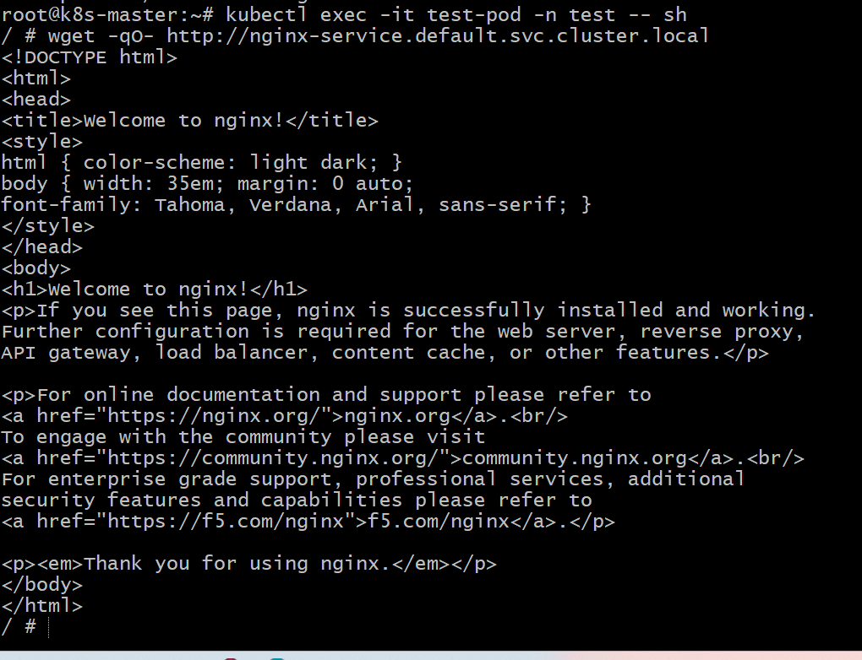

- Conclusion

In this task, we created an Nginx pod and NodePort service in the default namespace and another pod in the test namespace. Using Kubernetes Service DNS (`service-name.namespace.svc.cluster.local`), the pod in the test namespace successfully communicated with the service in the default namespace. This demonstrates how Kubernetes enables cross-namespace communication using internal DNS and services.

- Apply a LimitRange with a max limit/request ratio of 2 for memory in the performance-environment namespace, and test by creating a pod with mismatched resource requests and limits.

Step 1: Create LimitRange YAML

apiVersion: v1
kind: Namespace
metadata:
name: performance-environment

---
apiVersion: v1
kind: LimitRange
metadata:
name: performance-limitrange
namespace: performance-environment
spec:
limits:
- type: Container
maxLimitRequestRatio:
memory: "2"

Explanation:

* Namespace → creates an isolated environment called `performance-environment`
* maxLimitRequestRatio: 2 → memory limit cannot be more than 2× the memory request

Step 2: Create the YAML File

vi performance-limitrange.yaml

Paste the YAML and save.
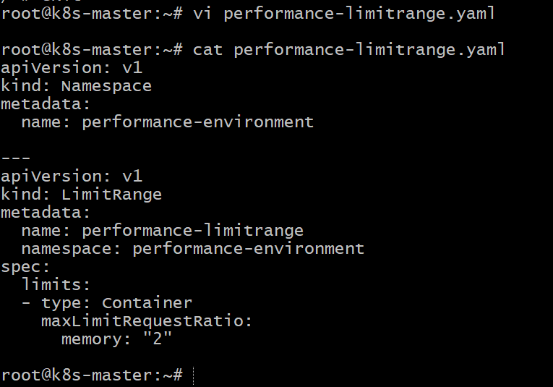

Step 3: Apply the LimitRange

kubectl apply -f performance-limitrange.yaml

Expected output:
namespace/performance-environment created
limitrange/performance-limitrange created
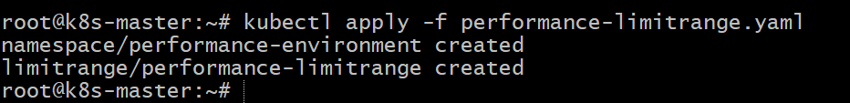

Step 4: Verify the LimitRange

kubectl get limitrange -n performance-environment

Detailed view:

kubectl describe limitrange performance-limitrange -n performance-environment

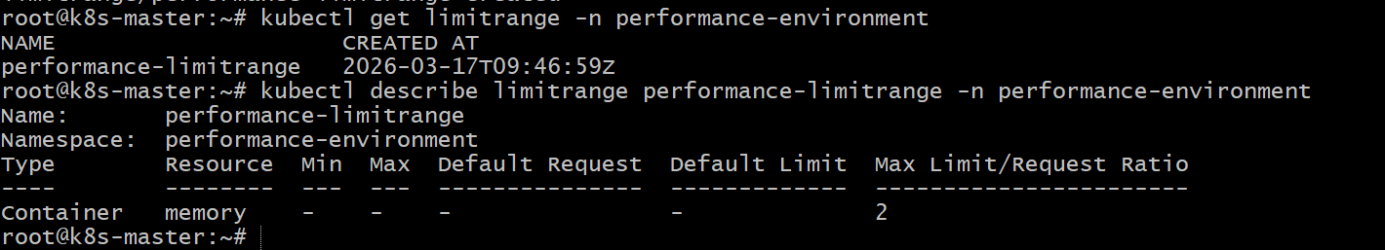

Step 5: Test with a Pod Having Mismatched Resources

Create a file **`test-pod.yaml`**

vi test-pod.yaml

apiVersion: v1
kind: Pod
metadata:
name: test-pod
namespace: performance-environment
spec:
containers:
- name: nginx-container
image: nginx
resources:
requests:
memory: "200Mi"
limits:
memory: "600Mi"

Here:

* Request = 200Mi
* Limit = 600Mi
* Ratio = 3 → exceeds allowed 2
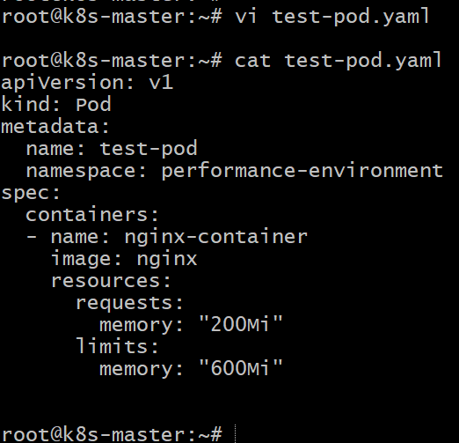

Step 6: Apply the Pod

kubectl apply -f test-pod.yaml

Expected result:

Error from server (Forbidden): maximum memory limit to request ratio per Container is 2

This shows the LimitRange policy is enforced.

- Conclusion

In this task, we configured a LimitRange in the `performance-environment` namespace to enforce a maximum limit-to-request ratio of 2 for memory. When attempting to create a pod with a memory limit three times larger than the request, Kubernetes rejected the pod creation. This demonstrates how LimitRange policies help enforce resource usage rules and prevent inefficient allocation of cluster resources.

